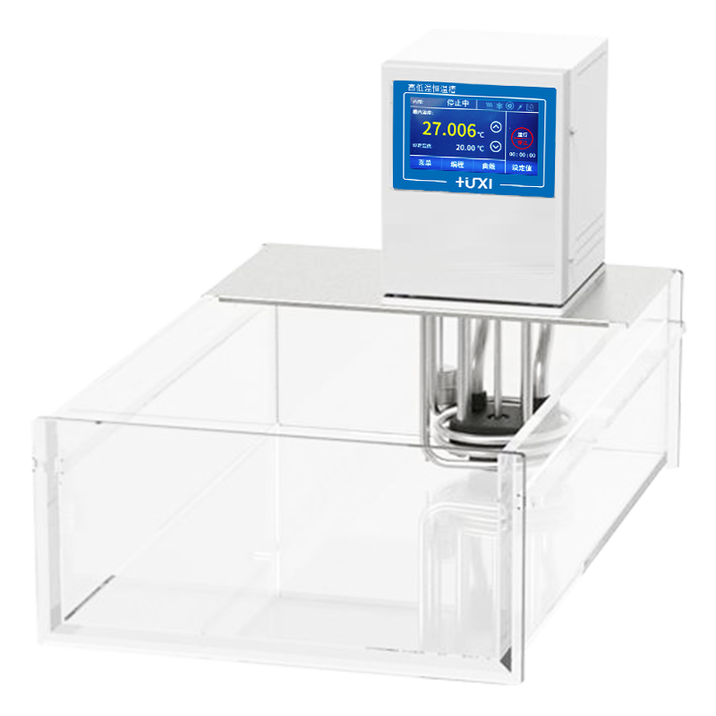

HLC-206A Open Type Thermostat

1、Application

Widely quoted with the rotary evaporator cooling; with the reactor system thermostat, biological reactor temperature control; for the cold trap to provide a cooling source; distillation system cooling; for the laboratory to provide the central cooling water; analysis of instruments, such as viscometer external circulation, temperature control of the rheometer, etc.; ultrasonic crushing, disperser cooling, etc.; external open container temperature control and circulation.
2、Features
- 1. Pressure suction pump: large flow, smooth water flow, no splash can withstand -80 ~ 300 ℃ temperature long time temperature work;
- 2. One-piece moulding: the parts in contact with liquid and vapour are made of high-performance stainless steel and high-performance materials;
- 3. centrifugal mixing technology: pressure suction pump has a jet jet mixing internal circulation technology, better temperature uniformity;
- 4. Imported temperature sensor: high-precision four-wire imported PT100 temperature sensor, single-point, two-point, three-point temperature calibration;
- 5. low liquid level protection: alarm can be light and sound at the same time to remind.

3、Technical Parameters
Model | HLC-206A
Item No. | 1032099001
Tank volume (L) | 6
Temperature control range (℃) | RT+10~100
Temperature control precision (℃) | ±0.03
Setting precision (℃) | ±0.1
Display precision (℃) | ±0.01
Heating power (W) | 2000
Display temperature mode | Touch Panel
Setting mode | Touch screen
Safety protection | Low level protection, high temperature protection
Use of ambient temperature (℃) | 5~32
Power supply voltage (V) | 200~230
Circulation mode | Internal and External Circulation
Flow rate (L/min) | 12
Lift(M)(Max/Rated) | 3.0/2.0
Circulation interface | 10mm Pagoda Fitting
Gross weight(kg) | 16
Tank opening(mm)(WxDxH) | 155*135*150
Overall Dimension(mm)(WxDxH) | 200*320*360

4、Packing List
Name | QTY
Main unit | 1 piece
DN8 connector | 2 pieces
M16*1 nut | 2piece
8*12 heat preservation pipe | 1.8m*2pieces
Certificate of Conformity (with warranty card) | 1piece
Instruction manual | 1piece

